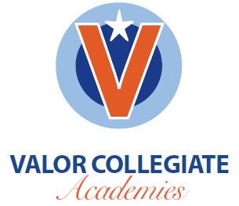

Fiscal Year 2016
- Student Recruitment Budget: $5,000
  - Includes design and print of direct mailers, one-page information sheets, and food, decorations and other items needed for student recruitment events at Valor’s campus

